In the advanced realm of IT, we delve beyond the user interface and delve into the intricate workings of the digital ecosystem. Here, hardware and software intertwine to create a complex dance of data manipulation and processing. Virtualization technologies like containers and hypervisors allow for efficient resource utilization, enabling multiple operating systems to run on a single physical server. This optimization translates to increased processing power and scalability for demanding applications.

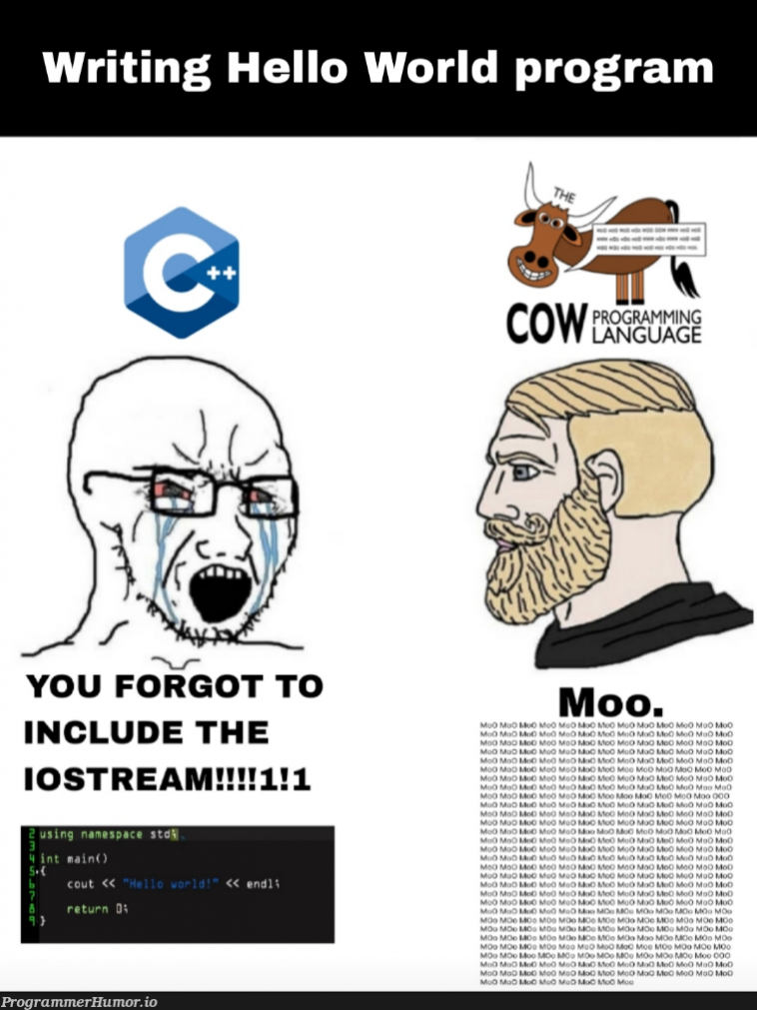

Network architecture becomes a strategic playground. Advanced professionals design and implement multi-layered networks, meticulously segmenting traffic to ensure security and optimal performance. Routing protocols like BGP (Border Gateway Protocol) and OSPF (Open Shortest Path First) become the language for efficiently directing data packets across vast geographical distances. Additionally, professionals leverage automation tools like Ansible or Puppet to streamline network configuration and management, ensuring consistency and reducing human error.

Security becomes a constant battle against ever-evolving threats. IT professionals employ a layered defense approach, utilizing firewalls, intrusion detection/prevention systems (IDS/IPS), and vulnerability scanning tools to identify and mitigate risks. Encryption becomes paramount for protecting sensitive data both at rest and in transit. Advanced professionals delve into secure coding practices and stay abreast of the latest hacking techniques to stay ahead of cybercriminals. This continuous vigilance ensures the integrity and confidentiality of data within an organization.